**Text of practice exercise Module 5.3**

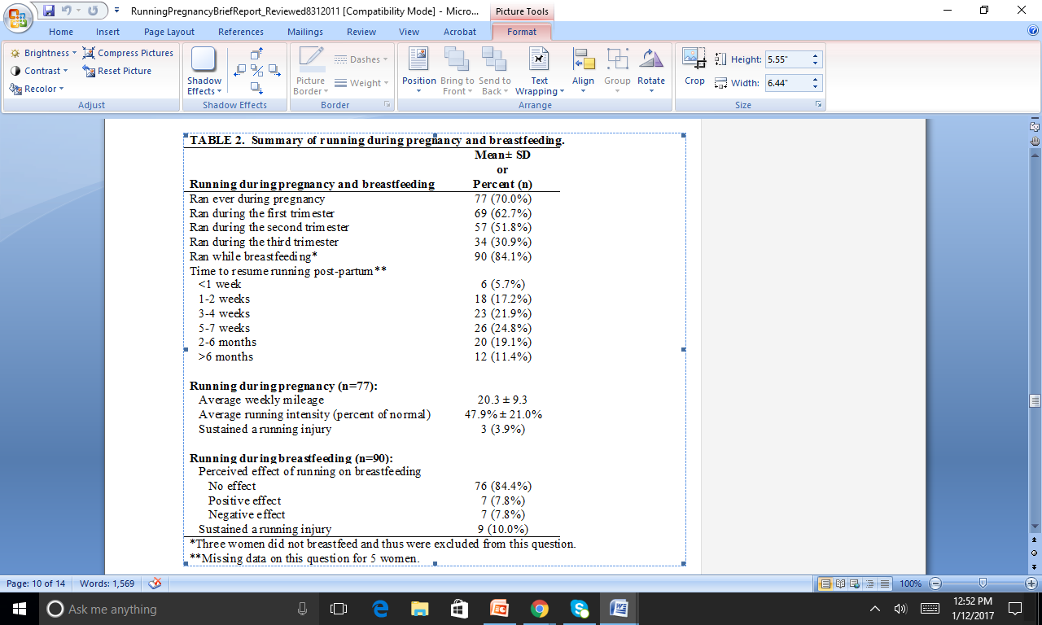

The majority of runners ran during pregnancy (70.0%, 77/110), with 62.7% running during the first trimester, 51.8% during the second trimester, and fewer than one third (30.9%) during the third trimester (Table 2). From the 77 women who ran during pregnancy, we observed the average weekly mileage during pregnancy for those who ran to be 20.3 ± 9.3 miles. Average running intensity was reported to be 47.9% ± 21.0% as a percent of non-pregnant running effort. A small number (3.9%, 3/77) reported sustaining a running injury while pregnant. About a quarter (24.8%) waited 5-7 weeks to resume running post-partum. A small fraction (5.7%) resumed running less than a week after giving birth. Some women (11.4%) waited more than six months post-partum to resume running.

Majority of pregnant ladies ran (Table 2). This is while most of them ran during the first semester and slightly more than half of them ran during the second semester. Running during while breastfeeding was most popular between them. The average weekly mileage was variant and it shows many women ran much more and much less than the average. Injuries during running was very low and can be ignored.

!!!There can be more than one answer. The answer below is one of them!!!

Seventy percent of runners ran during their pregnancy (n=77), and almost one third ran during their third semester (Table 2). On average, those who ran greatly curtailed their training –-- running 20.9 +_ 9.3 miles per week and cutting their intensity to half of their non-pregnant running effort. Three reported sustaining a running injury while pregnant. In the post-partum period, nearly on quarter resumed running by two weeks after giving birth; most resumed running by two months.